[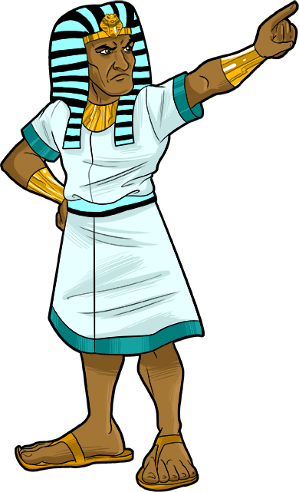](https://www.google.com/url?sa=i&url=https%3A%2F%2Fwww.pinterest.com%2Fpin%2F508484614166842182%2F&psig=AOvVaw257kmTiIrk-jG5MTFSiV7U&ust=1583688676870000&source=images&cd=vfe&ved=0CAIQjRxqFwoTCOjNxJ7yiOgCFQAAAAAdAAAAABAT)

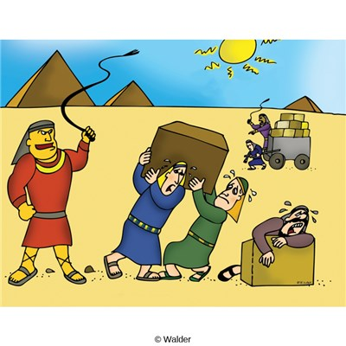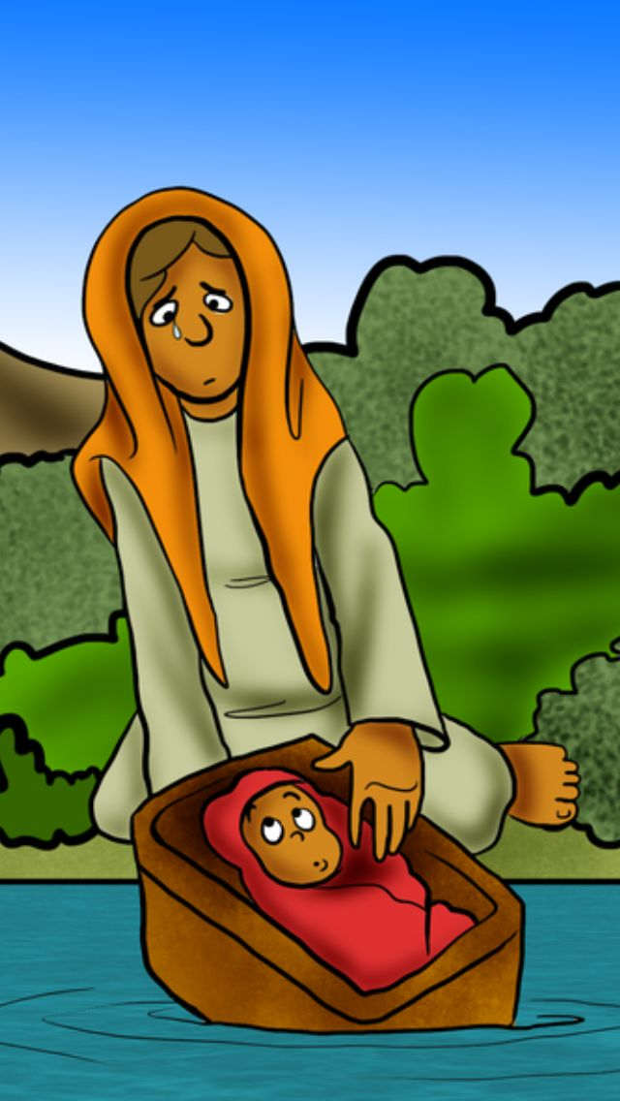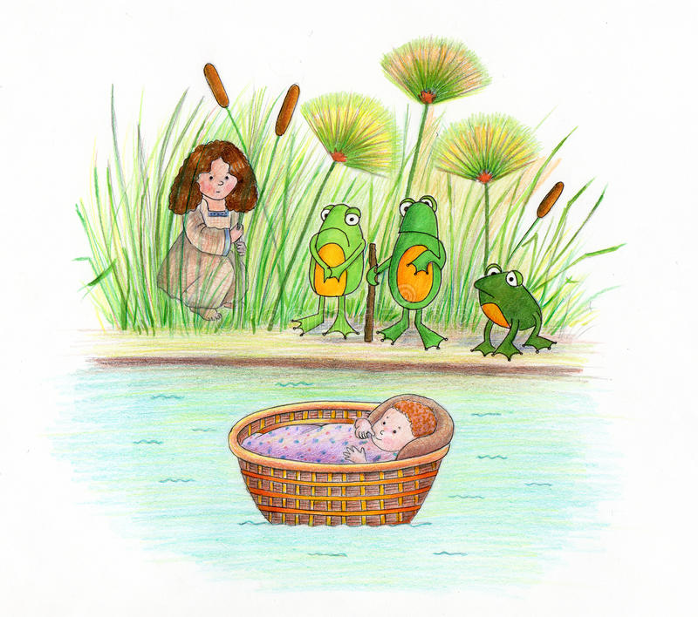

[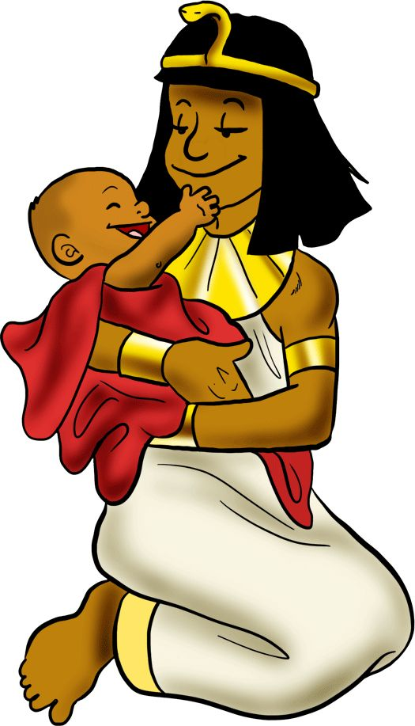](https://www.google.com/url?sa=i&url=http%3A%2F%2Fgetdrawings.com%2Fclipart-tag%2Fprophecy&psig=AOvVaw3qf5j-zR9XzwxLu849iKAJ&ust=1583688852017000&source=images&cd=vfe&ved=0CAIQjRxqFwoTCNC3z_HyiOgCFQAAAAAdAAAAABAQ)

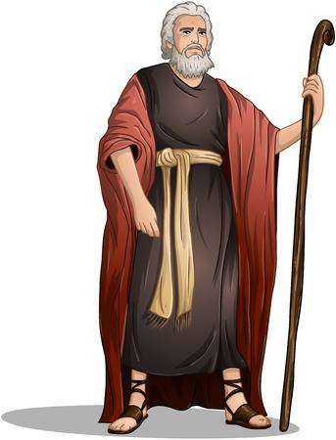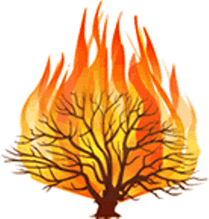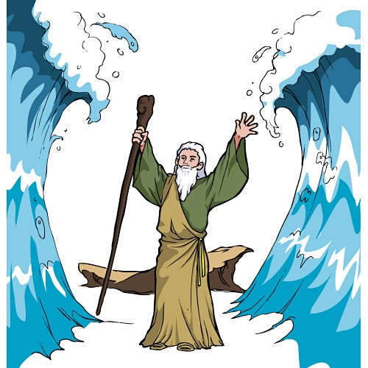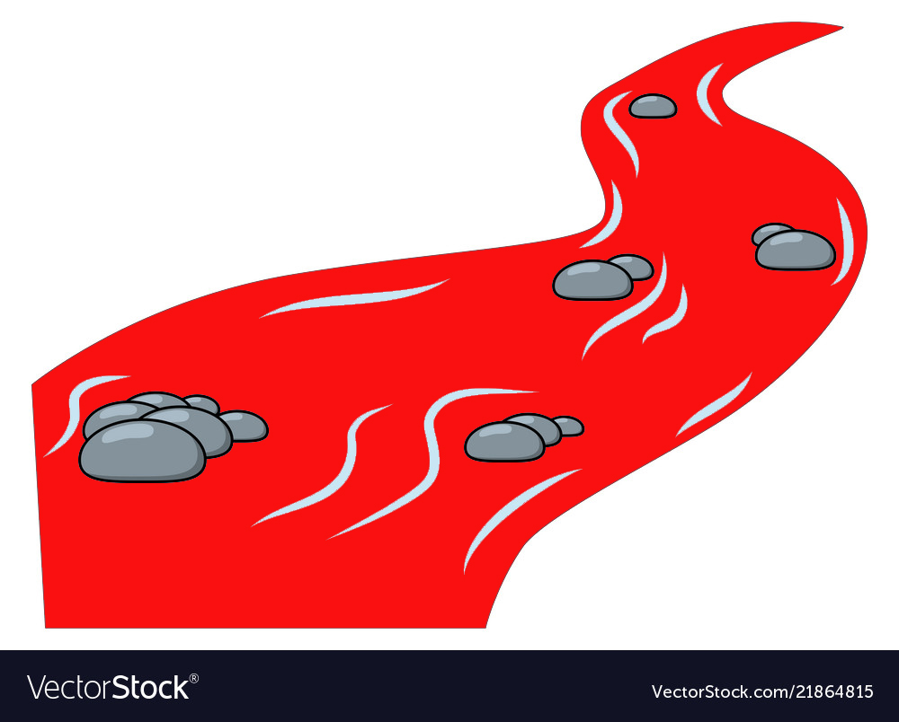











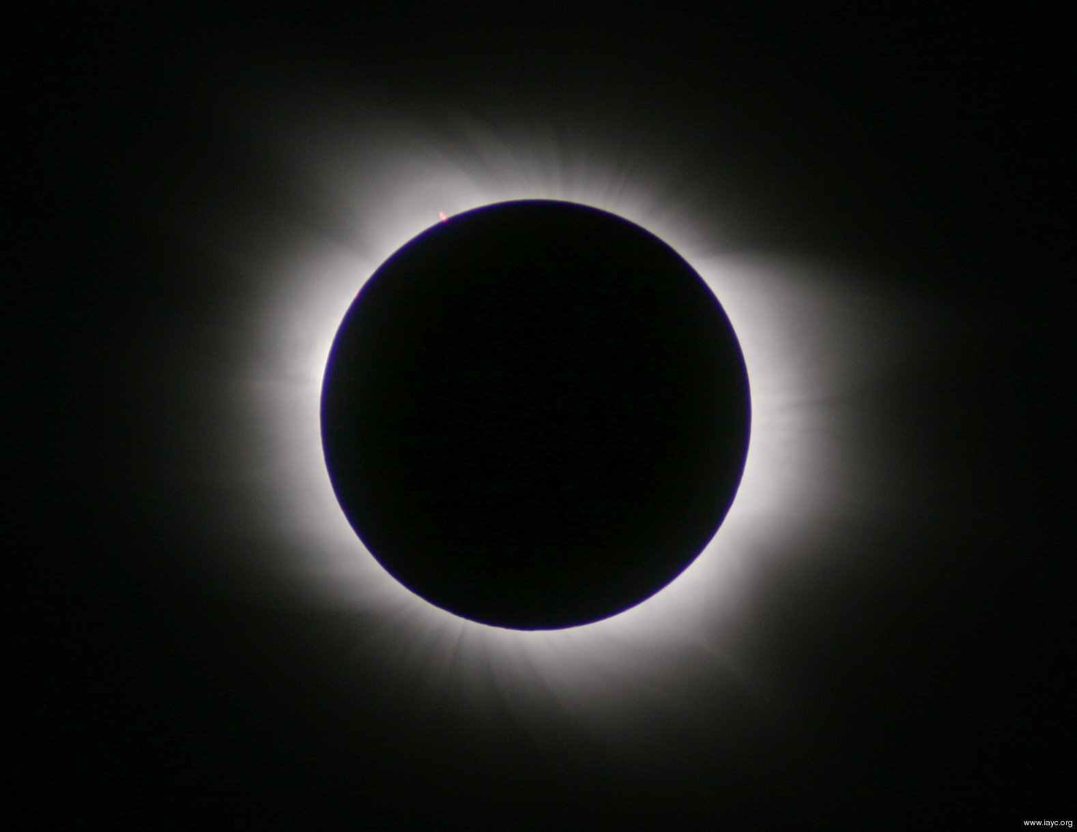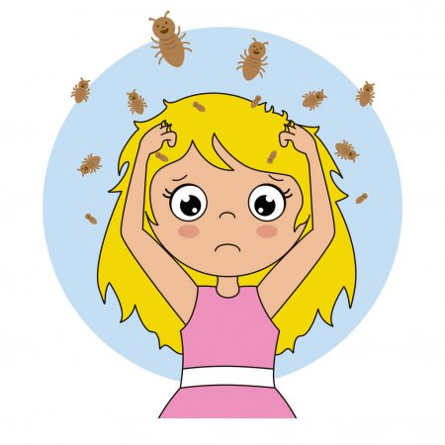

[](https://www.google.com/url?sa=i&url=https%3A%2F%2Fvectorskey.com%2Fproduct%2Fcold-sick-emoji-png-transparent-background-image-free-png-templates%2F&psig=AOvVaw1wM7e_7S64rLdJ4C744xol&ust=1583696822143000&source=images&cd=vfe&ved=0CAIQjRxqFwoTCPi8nMuQiegCFQAAAAAdAAAAABAO)[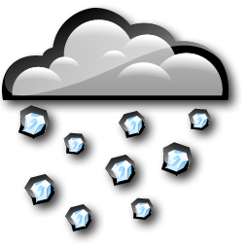](https://www.google.com/url?sa=i&url=https%3A%2F%2Fwww.clipart.email%2Fclipart%2Fhail-cloud-clipart-9379.html&psig=AOvVaw3uwA8yckBB-OcTfPNAHHh7&ust=1583696353257000&source=images&cd=vfe&ved=0CAIQjRxqFwoTCLjFyPKOiegCFQAAAAAdAAAAABAE)

[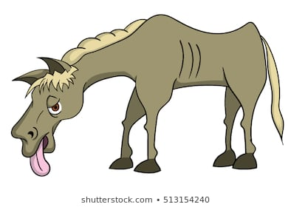](https://www.google.com/url?sa=i&url=https%3A%2F%2Fwww.shutterstock.com%2Fsearch%2Fsick%2Bhorse&psig=AOvVaw3U9Kfd96Lq2NWQAGL96YbK&ust=1583699291045000&source=images&cd=vfe&ved=0CAIQjRxqFwoTCNDek9-ZiegCFQAAAAAdAAAAABAD)